mail@cstfm.org
+852-30696823
2024 International Conference on Smart Transportation and Future Mobility (CSTFM 2024)
Oct. 18-20 | Shanghai, China | www.cstfm.org
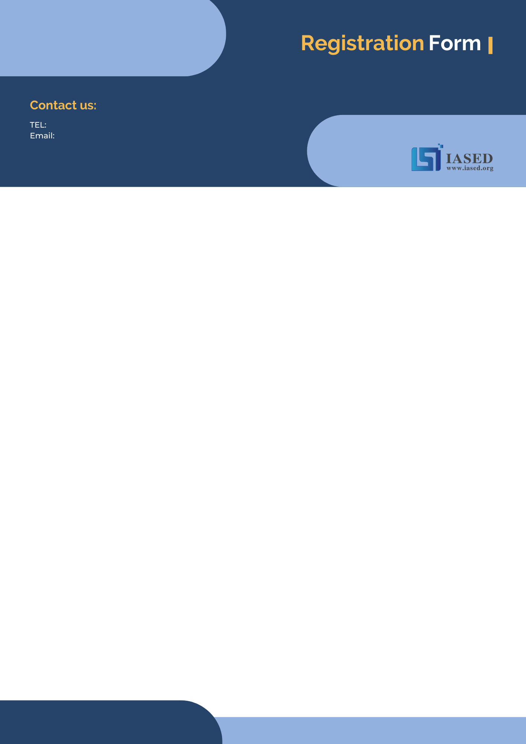
NOTE: Make sure to submit all required documents: 1. final paper (doc & pdf files), 2. completed registration form, 3. Payment Voucher to mail@cstfm.org (Mail Subject: Paper ID + Registration).
- ATTENDEE INFORMATION
*Full Name: | 1-inch-Photo here
*Position√: Prof. Assoc. Prof. Asst. Prof. Dr. Mr. Ms.
*Affiliation & Nation:
*Email:
*Mobile Phone:
*Alternative Liaison (Name & Mobile):
Address& Zip Code (for post use):
Catering (On-site conference on Oct. 19): Lunch Dinner
Special dietary√: Diabetic Vegetarian Halal food Other (please specify: )
Special requirements:

- PAPER INFORMATION
*Paper ID: *Paper Pages: *Extra Page(>5 pages):
*Paper Title:
*Authors:
*Whether to attend the on-site conference? Yes No
*Presentation Type√: Oral Poster Video
*Participation Certificate√: Softcopy Hardcopy I do not need the certificate
Student ID No. (student only):
IASED Member No. (member only):
* Receipt Issued to:

- PRICE INFORMATION
Onsite Conference
Category |  | Early Birds  (due by July 18, 2024) | Regular  Registration | On-site  Registration  (On Oct. 18, 2024) | Your  Choice
Full Paper Registration | Regular Author | 500USD | 550USD | 600USD
 | Student\  Committee | 450USD | 500USD | 550USD
 | IASED Member | 470USD | 520USD | 570USD
Abstract Registration | Regular Presenter | 400USD | 450USD | 500USD
 | Student\Committee Presenter | 350USD | 400USD | 450USD
 | IASED Member Presenter | 380USD | 430USD | 480USD
Listener\Co-Author |  | 250USD
Others
Additional Page | 70USD
Extra Paper Upload | 300USD
Printed Conference Proceeding | 60USD
Extra Banquet Ticket | 50USD
City Tour\Social Networking Event (Optional) | TBD
Notice
*If the paper exceeds 5 pages, the additional pages will be charged. The recommended general length limit is no less than 4 pages.
*All the presented and registered full papers will be published online.
*Onsite Conference—Full Paper Registration covers: publication fee + meeting sessions on Oct. 19 + 2 coffee breaks, 1 lunch, 1 dinner on Oct. 19 + conference kits.
*Onsite Conference—Abstract Registration covers: meeting sessions on Oct. 19 + 2 coffee breaks, 1 lunch, 1 dinner on Oct. 19 + conference kits. Only do a presentation (without publishing any papers).
*For "No shows", registration fee is nonrefundable.
*Shall the conference be delayed or prevented (directly or indirectly) by the reasons of natural disasters, war, strike(s), epidemic or any other events which could not be controlled, the organizing committee shall be under no liabilities. The organizing committee reserves the right to change the conference date, venue or form of the conference (online or on-site).
*Cancellation policy: Applicant should send the refund/cancellation requests to mail@cstfm.org. (The cancellation policy is available on the official website of the CSTFM 2024 on Registration Page: www.cstfm.org).
*Our payment system will not charge any extra fee, but the credit card payment may incur currency exchange charge which is charged by payers' bank, it should be borne by payers.

- PAYMENT INFORMATION

Bank Name | Bank of China Sichuan Branch
Beneficial name | CHENGDU FORWARD INFORMATION TECHNOLOGY
Account No. | 122625435544
CNAPS Code | 104651003017

- IASED MEMBER APPLICATION
Join IASED now to quality for member registration rates. Please compile and return the Membership Form along with your CV to membership@iased.org. Your application will be processed in 5 working days.
- OTHER
Finally, we suggest you write down a biographical sketch here, for use of making introductions by Session Chair before your presentation gets started.
20-120 Words (1-3 lines)

Contact us at IASED LinkedIn:
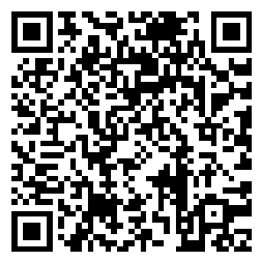
IASED LinkedIn
CSTFM 2024 Organizing Committee
Shanghai, China

